Motion Graphs

Describing the motion of an object is occasionally hard to do with words. Sometimes graphs help make motion easier to picture, and therefore understand.

Remember:
- Motion is a change in position measure by diastanece and time.
- Spoeed tells us the rate at which an object moves.
- Velocity tells the speed and direction of a moving object.
- Acceleration tells us the rate speed or duirection changes.

Distance-Time Graphs

Plotting distance against time can tell you a lot about motion. Let’s look at the axes:

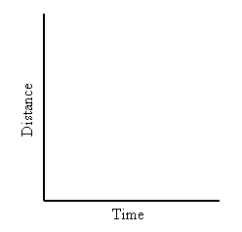
Time is always plotted along the bottom on the X-axis. The further to the right on the axis, the longer the time from the start.

Distance is plotted up the left had side of the graph on the Y-axis. The higher up the graph, the further the distance from the starting point.

If an object is not moving, a horizontal line is shown on a distance-time graph.
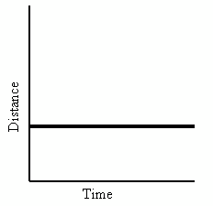

Time is increasing to the right but the distance does not change. The object is not moving so we say it is at rest.

If an object is moving at a constant speed, it means it has the same increase in distance in a given time.
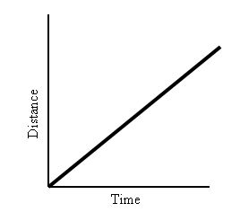
Time is increasing to the right, and the distance is increasing constantly with time. The object moves at a constant speed.

Constant speed is shown by straight lines on a graph.

Let’s look at two moving objects:
Both of the lines on the graph show that each object moved the same distance, but the object shown by the steeper dashed line gets there before the other one.
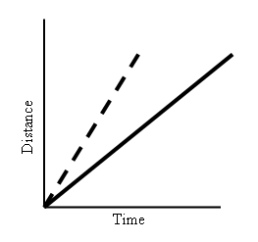
In this case, a steeper line shows the same distance travelled but in a shorter time.

Both lines are straight, so both speeds are constant.

Graphs that show acceleration look different from those that show constant speed.
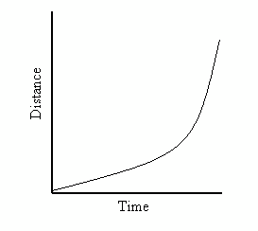
The line on this graph is curving upwards. This shows an increase in speed since the line is getting steeper.

In a given time, the distance the object moves is getting larger, it is accelerating.

Summary:

A distance-time graph tells us how far an object has moved with time.
- The steeper the graph, the faster the motion.
- A horizontal line means the object is not changing its position. If it is not moving, we say it is at rest.
- A downward sloping line means the object is returning to the start.

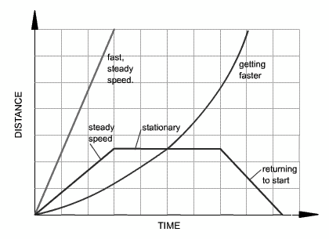

Examine the graphs below.

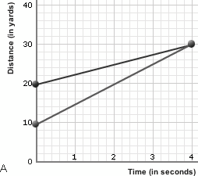
B
A
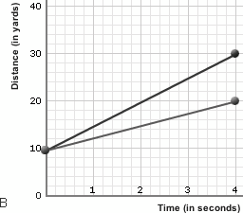

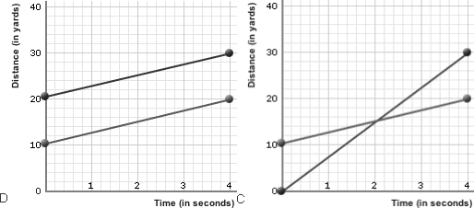
C
D

Which of the graph(s) shows that one of the runners started 10 yards further ahead of the other? Explain your answer.

In which of the graphs are both the runners moving at the same speed? Explain you answer.

Which of the graph(s) shows one runner running three times as far as the other in the same amount of time? Explain your answer.

The distance-time graphs below represent the motion of a car. Match the descriptions with the graphs. Explain your answers.
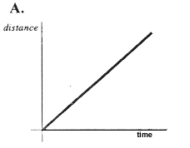

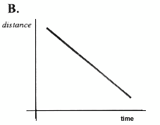

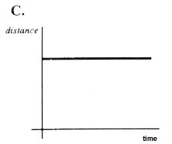

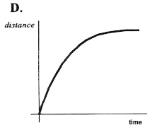

Descriptions:
- The car is stationary.
- The car is travelling away at a constant speed.
- The speed of the car is decreasing.
- The car is coming back at a constant speed.

Graph A matches description _____ because __________________________________.

Graph B matches description _____ because __________________________________.

Graph C matches description _____ because __________________________________.

Graph D matches description _____ because __________________________________.

Speed-Time Graphs (Can also be called Velocity-Time Graphs)

Speed-Time graphs look like Distance-Time graphs. Be Sure to read the axes labels. Time is platted on the X-axis and speed or velocity is plotted on the Y-axis.
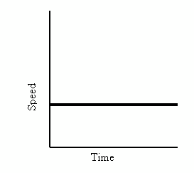
A straight horizontal line on a speed-time graph means that the speed is constant. It is not changing over time.

A straight line does not mean that the object is not moving on a speed-time graph.

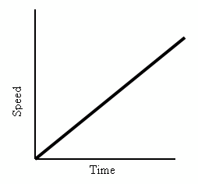

This graph shows increasing speed. The moving object is accelerating.

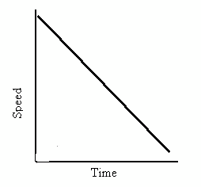

This graph shows decreasing speed. The moving object is decelerating.

What about comparing two moving objects at the same time?
Both the dashed and solid line show increasing speed.

Both lines reach the same top speed, but the solid one takes longer.

The dashed line has greater acceleration.
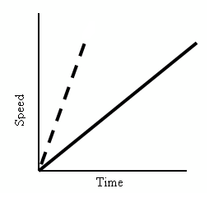

Summary:

A speed-time graph tells us how the speed of an object changes with time.
- The steeper the graph, the greater the acceleration.
- A horizontal line means the object is moving at a constant speed.
- A downward sloping line means the object is slowing down.
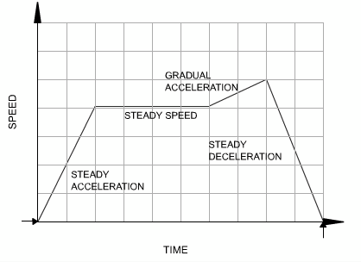

The speed-time graphs below represent the motion of a car. Match the descriptions with the graphs. Explain your answers.

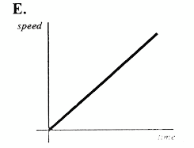

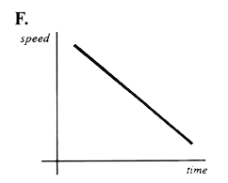

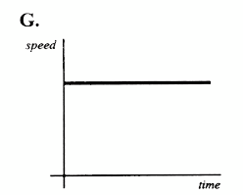

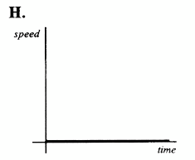

Descriptions:
- The car is stationary.
- The car is travelling at a constant speed.
- The car is accelerating.
- The car is decelerating.

Graph E matches description _____ because __________________________________.

Graph F matches description _____ because __________________________________.

Graph G matches description _____ because __________________________________.

Graph H matches description _____ because __________________________________.

Questions:

Look at the graph below. It shows how three runners ran a 100-metre race.
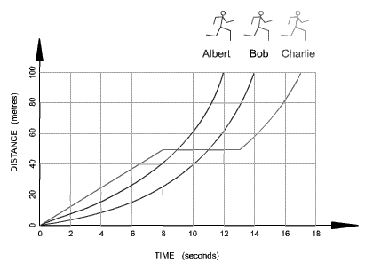

Which runner won the race? Explain your answer.

Which runner stopped for a rest? Explain your answer.

How long was the stop? Explain your answer.

How long did Bob take to complete the race? Explain your answer.

Calculate Albert’s average speed.

Calculate Bob’s average speed.

Calculate Charlie’s average speed.

The graph below shows how the speed of a bus changes during part of a journey.
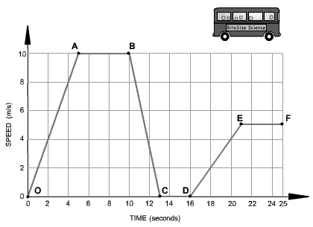

Chose the correct word from the following list to describe the motion during each segment of the journey to complete the sentences.

- Accelerating
- Decelerating
- Constant speed
- At rest

Segment O-A: The bus is _________________ . Its speed changes from 0 to 10 m/s.

Segment A-B: The bus is moving at a _________________of 10 m/s for 5 seconds.

Segment B-C: The bus is _________________ . It is slowing down from 10 m/s to rest.

Segment C-D: The bus is _________________ . It has stopped.

Segment D-E: The bus is _________________ . It is gradually increasing in speed.

Segment E-F: The bus is moving at a _________________of 5 m/s.

Use the graph to calculate the acceleration of the bus from O-A.

Use the graph to calculate the deceleration of the bus from B-C.

Use the graph to calculate the acceleration of the bus from D-E.

